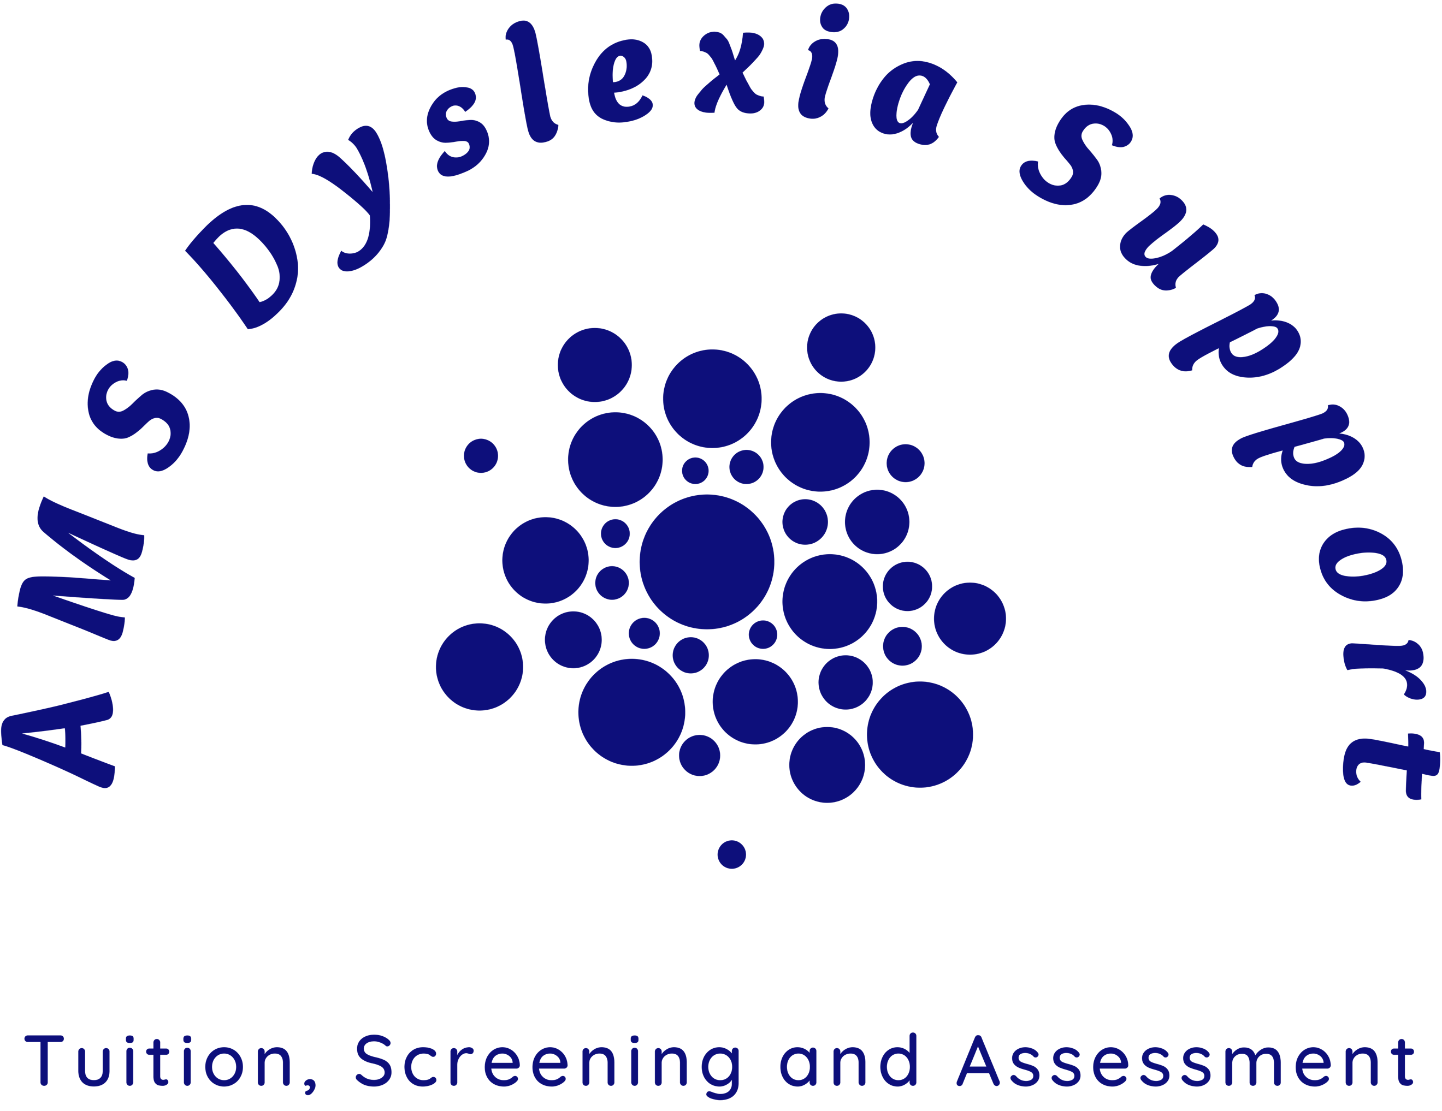

Booking Pack for an assessment concerning
Dyslexia or SpLD in Maths / Dyscalculia

Ages16-18 in school or college

Name: ……………………………………………………….……………………

Age and Date of Birth: …………….……………………………………………

Diagnostic Assessment (post-16 / adult)
Booking Form

Please email the completed booking pack to ams@amsdyslexiasupport.co.uk or post it to AMS Dyslexia Support, 1 Channel Road, Clevedon BS21 7DR.

This section is to be completed by the parent or guardian making the booking.

Details of Booking
Name(s) of Parent/Carer
Home Address:

Contact Telephone numbers:

Contact Email:

Name of person being assessed:

Please indicate the assessment required: |  | Tick here
Dyslexia | £475
SpLD in Maths/Dyscalculia | £475
Joint Dyslexia and SpLD in Maths/Dyscalculia | £650

Terms and Conditions for Diagnostic Assessments

Privacy Policy:

- AMS Dyslexia Support is committed to protecting individuals’ privacy. Accordingly, all personal data collected will be subject to our Privacy Policy. For more information, please see our website: https://www.amsdyslexiasupport.co.uk/forms.

How your information is used:
AMS Dyslexia Support will not pass your details to any 3rd parties. If you need any further information, please write to us at ams@amsdyslexiasupport.co.uk
Payment method
£100 non-returnable deposit is required at the time of booking, with the final amount due on the assessment day. Payments can be made by credit/debit card via our website https://www.amsdyslexiasupport.co.uk/shop-1 or BACS.
The account details, for BACS purposes, are:
Account Name: AMS Dyslexia Support
Sort Code: 40-17-50 (HSBC)
Account Number: 71544136
Authorisation

- I/we give permission for AMS Dyslexia Support to assess my / our child.
- I/we have read AMS Dyslexia Support’s Privacy Policy and agree that the personal data provided is used and stored as stated in the Privacy Policy.

Signed: |  | Signed:
Print name: |  | Print name:
Date: |  | Date:
Relationship to the person being assessed: |  | Relationship to the person being assessed:

The remainder of the form should be completed by the person being assessed, with the support of their parent or guardian if required.

Details of Booking
Full Name:
Date of birth: |  | Age:
Home Address:

Contact telephone number (if over 18):

Contact email (if over 18):
Terms and Conditions for Diagnostic Assessments

Privacy Policy:

- AMS Dyslexia Support is committed to protecting individuals’ privacy. Accordingly, all personal data collected will be subject to our Privacy Policy. For more information, please see our website: https://www.amsdyslexiasupport.co.uk/forms.

How your information is used:
AMS Dyslexia Support will not pass your details to any 3rd parties. If you need any further information, please write to us at ams@amsdyslexiasupport.co.uk

Authorisation

- I confirm that the information provided in this questionnaire is correct.
- I have read AMS Dyslexia Support’s Privacy Policy and agree that the personal data provided and the subsequent report are used and stored as stated in the Privacy Policy.
- I respect the confidential nature of the assessment report and will only circulate it to relevant professionals for the purpose for which the report is intended.

Signature:
Name (print):
Date:

CONFIDENTIAL PRE-ASSESSMENT QUESTIONNAIRE

Please note that the information recorded in the questionnaire will assist with the assessment. As such, some of this information may be recorded in the final assessment report. If you have any sensitive/confidential information that you think is relevant but would prefer not to disclose in this questionnaire or have it recorded within the report, please consider sharing this confidentially with the person assessing and agree on how this information is used.

Full Name (please include Mr/Mrs/Ms/Miss): |  |  |  |  | Date of Birth:
Known as: |  |  |  |  | Age:
Country of Birth: |  |  | Date moved to the U.K.:
Are you adopted? | Yes |  | No |  |  | I prefer not to say
How do you identify yourself? | Male | Female |  | Non-binary |  |  | I prefer not to say

Health and Developmental History

Early Development
Were you both prematurely? | Yes | No
If yes, how early were you born?

If yes, please provide details of any additional hospital intervention/care required and for how long.

Did you meet normal developmental milestones on time, such as walking, talking, or riding a bike? | Yes | No
If no, please provide further details:

Have you ever seen any other specialists (e.g. speech specialists) or been assessed for learning difficulties such as dyslexia or dyscalculia? | Yes | No
If yes, please give further information:

Have you ever suffered from any serious illnesses? | Yes | No
If yes, please give details, including any mental health difficulties (including anxiety/depression):

Are you currently taking any medication? | Yes | No
If yes, please provide details:

Is your hearing within normal limits? | Yes | No
If no, please give details:

Vision and Visual Difficulties
In order to proceed with the assessment, you MUST have had a sight test within the last 2 years. In some cases, difficulties with reading (needed in literacy and maths) are caused by visual problems that are not related to learning. Therefore, if, having answered the questions below, you suspect there are visual difficulties* you MUST discuss this at the eye test so that the Optician (Optometrist) carrying out the eye test can refer you to an Ophthalmologist for further investigation before the assessment.

*Visual difficulties should be investigated if you answered ‘always’ or ‘sometimes’ to several questions.
Have you had any history of visual difficulties/problems with sight / visual impairment? |  | Yes | No
If yes, provide further details:

What date did you last have a sight test by an optometrist (optician)?

Was any prescription made? |  | Yes | No
If yes, were you advised to wear the prescription glasses/contact lenses for distance (e.g. for watching television or driving) or near (e.g. reading) or both?

Do you wear the prescribed glasses/contact lenses?  If yes, you must bring them with you to the assessment unless they are for distance only. |  | Yes | No
Have you ever used coloured overlays / colour-tinted glasses? |  | Yes | No
If yes, please provide the following information:
Who advised and provided them?

Why were they recommended?

Did they help? If yes, in what way?

Do you still use them? If not, why not?

Reading and Near Work Activity
Approximately how many hours per working/study day do you spend at a screen (phone, tablet, computer), etc.?
Approximately how many additional hours per day do you spend reading books, newspapers, comics or other paper-based texts?
Has your screen /reading /near-work time increased recently? If so, by how much?

 | Never | Rarely | Sometimes | Often | Always
Do you get headaches when reading?
Does reading make your eyes feel sore, gritty or watery?
Does reading make you feel tired or sleepy?
Do you become restless, fidgety or distracted when reading?
Do you become less comfortable the longer you read?
When do you prefer dim light to brighter light for reading?
Does reading from white paper seem too bright or glaring?
Do parts of the white page between the words form patterns when you read?
Does the print or background shimmer or appear coloured as you read?
Does print appear to jitter or move on the page as you read?
Do you screw your eyes up when reading?
Do you rub your eyes to relieve the strain when you are reading?
Do you move your eyes around or blink to keep the text clear when you are reading?
Do you use a marker or your finger to stop you losing the place when you read?
Do you cover or close one eye when reading?
Do you lose your place when reading?
Do you re-read or skip words or lines when reading?
Does text appear blurred or go in and out of focus when you read?
Do objects in the distance appear more blurred after you have been reading?
Do the words on a page or in a book appear double when reading?
*N.B. Response categories for this protocol: Always = every day. Often = several times a week but not necessarily every day. Sometimes = 2-3 times a month. Rarely = only once every few months / a year

Family History

Have any other (immediate or wider) family members experienced difficulties with:
Reading? | Yes | No
Writing? | Yes | No
Spelling? | Yes | No
Maths? | Yes | No
Learning? | Yes | No
If yes, please give details:

Language and Linguistic History

Are any other languages spoken at home? | Yes | No
If yes, please give details:

Education History

Name and address of current school/college:

Name and address of previous school/college(s) attended, with dates:

What subjects are you good at?

How old were you when your difficulties were first noticed?

Do you have a good relationship with your teachers/lecturers? | Yes | No
Do you feel (or have you previously felt) that you cannot keep up academically with the others in your class? | Yes | No

Do you have (or previously had) any difficulties at school with any of the following?
Reading | No | Slight | Moderate | Severe
Spelling | No | Slight | Moderate | Severe
Writing | No | Slight | Moderate | Severe
Mathematics | No | Slight | Moderate | Severe
Essays | No | Slight | Moderate | Severe
Revision | No | Slight | Moderate | Severe
Sport & games | No | Slight | Moderate | Severe

Do you currently have (or previously had) any specialist help at school or with an external tutor? | Yes | No
If Yes, please give details (e.g. Teaching assistant, extra time in exams, EHCP, specialist tuition)

Was your schooling disrupted in any way? | Yes | No
If yes, please give details:

Work History

Are you currently working part-time alongside your studies? |  | Yes | No
Name of employer:

What is your current job title/role?
Please give details of any previous work you have done:

Have you taken any other courses since leaving school?  If Yes, please give the details below: |  |  |  | Yes | No
College | Date | Course | Qualification gained

Current Situation

Briefly explain why you wish to be assessed:

Literacy

Do you have problems with:
Word Reading
Identifying the sounds in words? | Yes | No
Reading aloud and fear of getting it incorrect? | Yes | No
Reading fluently and accurately? | Yes | No
A slow reading speed? | Yes | No
Needing to track each word when you read using your finger or a bookmark? | Yes | No
Do you have problems with:
Comprehension
Understanding what you have read? | Yes | No
Do you have problems with:
Listening skills
Differentiate between different voices that you hear when at school/college/work? | Yes | No

Do you have problems with:
Writing
Taking notes, e.g. at meetings or lectures? | Yes | No
Transferring information from one source to another? | Yes | No
Producing written reports, essays or other lengthy documents? | Yes | No
Proofreading your written work? | Yes | No
Summarising information? | Yes | No
Identifying key points when faced with large quantities of information? | Yes | No
Filling in forms or writing cheques correctly? | Yes | No

Do you sometimes muddle up words in sentences so that they don’t make sense or are grammatically incorrect? | Yes | No
Do you write long, rambling sentences? | Yes | No
Do you tend to write down everything as it comes into your head? | Yes | No
Do you avoid writing in front of others? | Yes | No
Do you miss out full stops, commas and other punctuation marks? | Yes | No

Spelling
Do you feel your work contains a large number of spelling errors? | Yes | No
Do you misspell ‘easy’ words when filling in forms in front of others? | Yes | No
Do you miss out little words or the endings of words? | Yes | No
Do you avoid using words you cannot spell? | Yes | No

Number, Estimation and Calculation

Do you:
Tend to forget mathematical operations that are used infrequently? | Yes | No
Find it hard to calculate sums in arithmetic without a calculator? | Yes | No
Find it difficult to do calculations in your head? | Yes | No
Find it hard to remember the times tables? | Yes | No
Struggle to understand fractions and/or decimals? | Yes | No
Find it hard to understand the maths required when considering a worded maths problem? | Yes | No
Find it challenging to estimate the amount required when cooking / baking? | Yes | No
Find it difficult to understand timetables and graphs? | Yes | No
Find the concept of time challenging? | Yes | No
Find it hard to manage your day-to-day finances? | Yes | No

Planning and Organisational Ability

Do you have problems with:
Planning ahead? | Yes | No
Organising yourself? | Yes | No
Prioritising your workload? | Yes | No
Meeting deadlines? | Yes | No
Working under pressure of time (e.g. in examinations)? | Yes | No

Do you put off starting tasks until the last minute? | Yes | No
Do you get confused over dates and times and miss appointments? | Yes | No

Memory, Attention and Concentration
Do you have difficulties remembering instructions/new information? | Yes | No
Do you often lose concentration? | Yes | No
Do you sometimes lose track of where you are in a task and have to start again? | Yes | No
Do you experience eye strain when looking at a computer screen for extended periods? | Yes | No
Does writing tend to look blurred or move about on the page when concentrating for extended periods? | Yes | No
Do you find it hard to remember sequences of letters or numbers, such as telephone numbers or car registrations? | Yes | No

Social and Communication Skills

Social:
Are there any situations when you do not feel confident? | Yes | No
Do you have any difficulties developing good working relationships? | Yes | No
If yes, why?

Do you have any difficulty developing friendships? | Yes | No
Do you find it hard to make eye contact with people? | Yes | No
Do you feel uncomfortable in social situations? | Yes | No
If yes, please give details:

Communication - do you:
Find it difficult to think of the words to express what you want to say? | Yes | No
Can you give examples?

Lose track of what you want to say or what other people are saying? | Yes | No
Sometimes find you have completely misinterpreted what you have been asked? | Yes | No
Have difficulty following the conversation in group discussions? | Yes | No
Get confused or freeze up if you have to speak or read aloud in public? | Yes | No
Sometimes find it hard to take telephone messages and pass them on accurately? | Yes | No

Orientation:
Do you have difficulty telling left from right? | Yes | No
Do you find it hard to remember directions? | Yes | No
Do you have difficulties reading road signs, especially when driving? | Yes | No
ls map reading, or finding your way to a strange place confusing? | Yes | No

Coordination and Dexterity - do you:
Have poor coordination? | Yes | No
Find it difficult to learn how to do practical tasks? | Yes | No
Find it difficult to work with small tools or components? | Yes | No
Have difficulties in using a keyboard or mouse? | Yes | No
Often drop things or bump into things? | Yes | No
Did you find it difficult to learn to drive? | Yes | No
Do you have any current difficulties with driving? | Yes | No

Strengths

Please provide information about your strengths, what you are good at, the hobbies you enjoy, etc.:

Any Other Information

Did anyone help you to complete this questionnaire? | Yes | No
If yes, please provide further details:

Do you receive assistance with day-to-day living, for example, from a carer? | Yes | No
If yes, please provide further information on what you need help with, such as washing and dressing, managing your finances, etc.

Have you ever been told you have, or been diagnosed with, a learning disability, e.g. moderate learning difficulty, severe learning difficulty, or global learning difficulty? | Yes | No
If yes, please give details:

Do you receive the Personal Independence Payment (PIP) or the Disability Living Allowance (DLA)? | Yes | No
If yes, please provide details:

Please summarise your difficulties and say if there is anything you would like help with in particular. Have any strategies worked for you so far? For example, do you mainly think in pictures or words or both when planning your work?
Please include any information which you feel may be relevant.

Any other information not covered within this questionnaire that we should know before the assessment:

Signature:
Name (print):
Date:

